**CALIBRATION TOOL APP**

This application has been created having in mind the requirements of the different locations, therefore if you see something not familiar to you it is to reflect that.

* The main form contains all info about tools. Highlighted in red are the tools with next calibration date equal or smaller than today’s date and need to be calibrated. The tools highlighted in blue instead are the ones that are assigned to someone and not yet been returned
* The records are uniquely identified by an automatically created Record ID, not the tool ID, because the latter was not unique in all locations.
* Also, you can sort and filter columns at the top of each column.

**MAIN PAGE**

**ENTER A NEW RECORD/S**

* Users can enter a new record by clicking on the button “Add New Tool”
* When entering a new record the calibration interval is required because the system, based on that and on the calibration date you will enter in the “Create Calibration Record” screen, it will calculate the next calibration date.
* For Calgary records there is an option for status N/A.

**EDIT RECORD/S**

* One can edit a record by selecting a record and then clicking on the button “Edit Tool”. The latter will open up a new screen where you can edit the record data.

**EXPORT GRID**

* A user can export to excel whatever is showing in the grid on the main page by clicking on button “Export Grid” after having applied the desired filters
* To apply a filter the user must click on the filter icon which shows for each column after the mouse is hovered on the right side of the column name
* For example, to get the monthly report of the tools that need calibrated the current month and that may or may not include preventative maintenance records, a user can:
* filter the Next Calibration Dt column to select only the current month
* filter the Preventative Maintenance column to include or not this type of records
* finally click on button “Export Grid”
* For Preventative Maintenance column, if a user does not want to use the filter anymore the Clear Filter button under the filter menu must be clicked

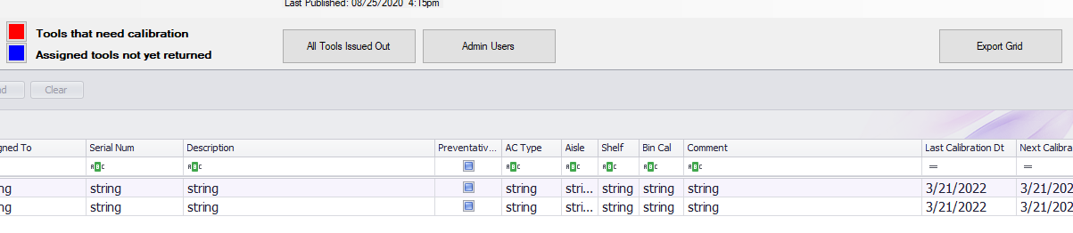

* If a user wants to clear all filters without clearing the filter for each single column: right-click on any column, select “Filter Editor”, click on the “x” of each filter and then click on “Apply”

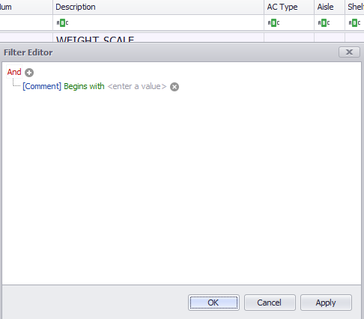

**MANAGE VENDORS AND MANUFACTURERS**

* You can add/delete vendors and manufacturers on their relative screen which you can access by clicking on “Manage Vendors” or “Manage Manufacturers” buttons, respectively.
* In their respective screens you can add or delete a vendor or manufacturer the same way: that is, by clicking on the plus sign to add a new record or by clicking on the minus sign, after selecting the record, to delete a record.
* The vendors and manufacturers you enter in these screens are the ones you can choose from the vendor and manufacturer dropdowns you find anywhere in the application. Therefore, it is important to maintain the tables in these screens.
* Click on “Save” when done with all your changes/additions/deletions.

Both screens look similar, this is how: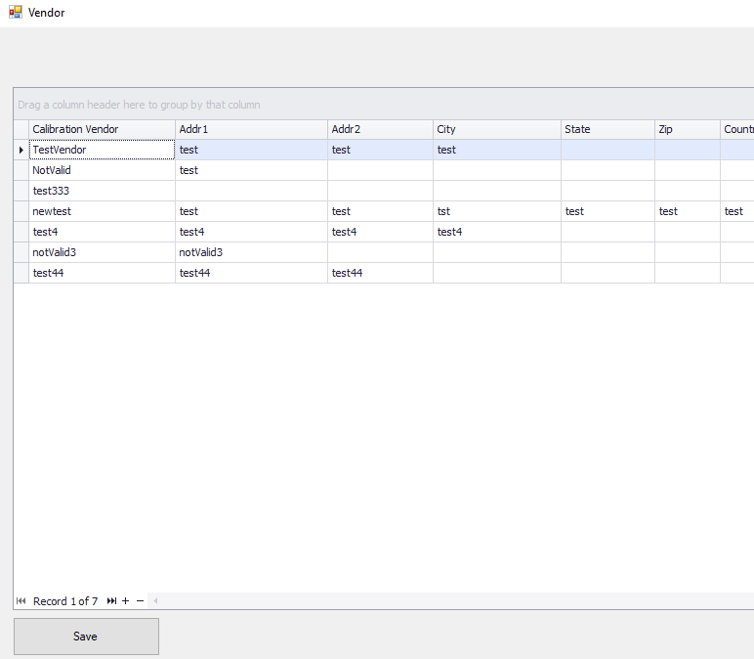

**TRACK CALIBRATIONS**

* One can enter calibration info for a tool by clicking on “Create Calibration Record” button after selecting a record on the main page.

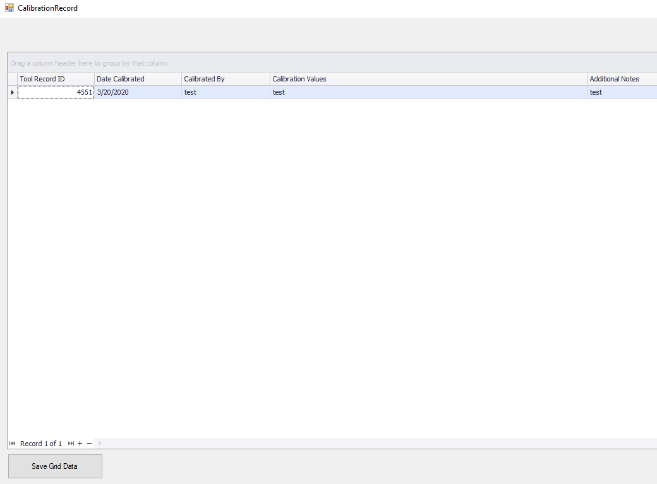

* Tool Record ID will be filled out automatically and of course it would be the same as the Record ID of the tool one selects on the main page.
* Calibrated By is mandatory to be entered
* After creating a calibration record on this screen, Last Calibration Date on the main screen will automatically populate with the Date Calibrated of the last record entered. Also, Next Calibration Date on the main screen will automatically populate, based on the Calibration Interval, with the next date the tool must be calibrated.
* Click on “Save Grid Data” when done with all your changes/additions/deletions.

**TOOL TRACKING**

* This screen will contain info about who the tool has been issued to.

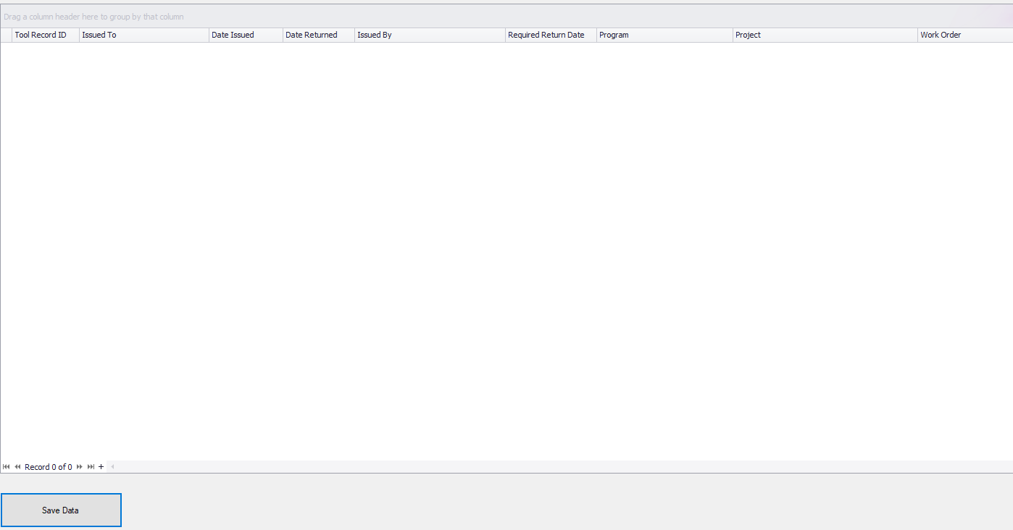

* On this screen, as in every other screen of this application(except the main screen), you can add records by clicking on the plus sign or delete a record after it has been selected by clicking on the minus sign.
* The Issued To column is mandatory to be entered.
* Issued by is systematically filled with the username of the person using the app.
* Requested Return Date defaults to today’s date but it can be changed.
* Program is entered by you, but the system will remember the programs you enter and they will appear in the dropdown the next time you use this screen.
* Click On “Save Data” after completing with additions/deletions/modifications.

**ALL TOOLS ISSUED OUT**

* This screen presents all the tools that are currently issued to someone(with no return date)
* This table cannot be managed from here and it is only for viewing.

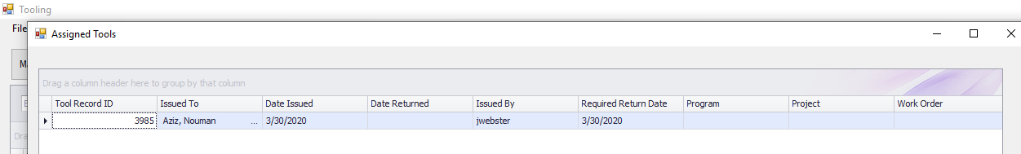

**ADMIN USERS**

* On this screen one administers who has access to the app.
* The Username is required.
* After making your additions/deletions/modifications, click on “Save” button.

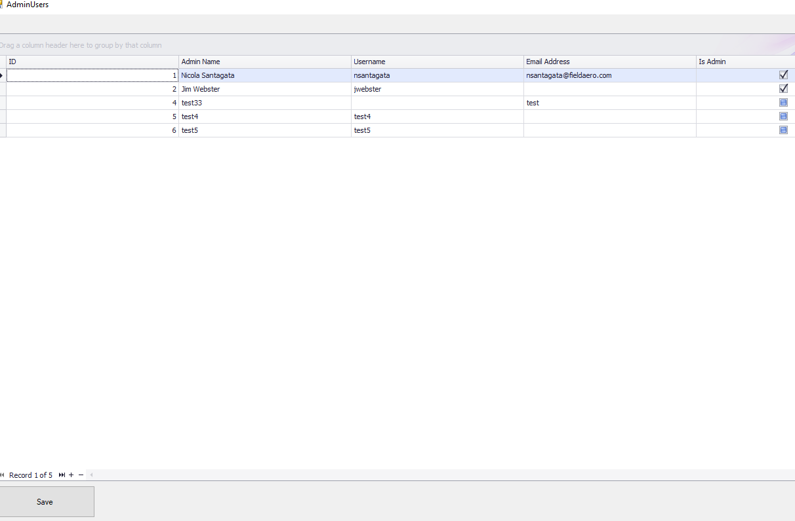

**REPORTS**

* One can access the report screens from the Reports menu at the top-left corner of the main page.

There are 2 reports:

* Report 1 - You can get a report based on all the tools (from main screen) and filter with all the parameters shown in the screenshot below.

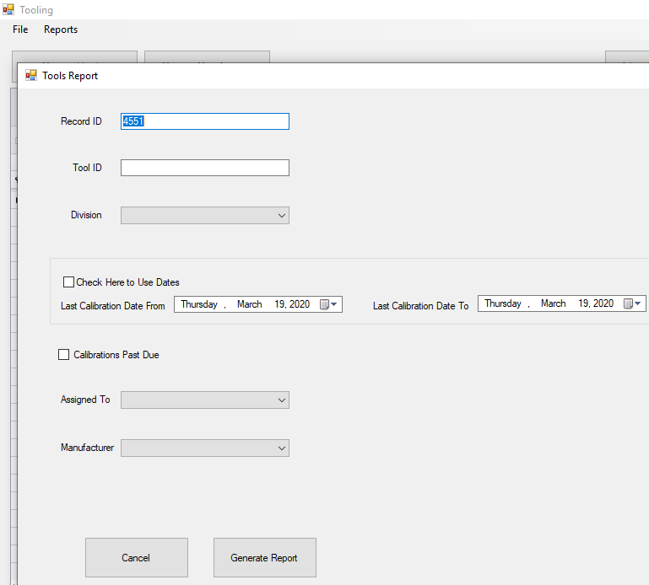

* Record ID is pre-filled and taken from the record you have selected on the main screen, but it can be changed or empty.
* If one chooses to use the Last Calibration dates filter you would have to check “Check Here to Use Dates” in order for the filter to work.
* Report 2 - The second report relates to the calibration records of each tool.
* Record ID is pre-filled and taken from the record you have selected on the main screen, but it can be changed or empty.

